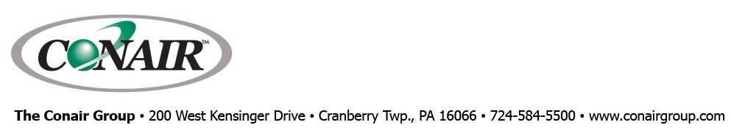
PRESS RELEASE Date: March 29, 2021

Contacts: Scott Collins, Collins Marketing Communications, +1-216.382.8840; scollins@collins-marcom.com

Conair Invites Industry to Virtual Plastics Processing Technology Summit, May 18-20

Conair, with cooperation from three other plastics industry leaders – Arburg, Milacron, and Davis-Standard – is hosting a three-day virtual event that will present not only new products, but also expert-led discussions about current market conditions and the latest processing methods and technologies on May 18, 19, and 20.

Free and open to the global plastics industry, the three-day Conair Summit 2021 offers experts hosting a series of market keynotes and technology-focused discussions, each highlighting current conditions and challenges, offering new manufacturing processes and solutions, and addressing participant questions. Live Summit presentations will occur from 10 AM – 3 PM, EDT. The agenda of discussion topics includes:

Tuesday, May 18
- Leveraging Digital Technology to Optimize Equipment Operation & Maintenance
- The Science Behind Smart Resin Conveying
- Addressing Recent Trends in the Plastics Medical Device Market

Wednesday, May 19
- Staying Competitive & Profitable in an Evolving Automotive Market
- The Changing Extrusions Market
- Advantages of the Groove Feed Extruder for Pipe and Profile Applications
- Improving Size Reduction and Scrap Processing

Thursday, May 20
- Advances in Heat Transfer Technology
- Overcoming Challenges in Plastics Packaging Processing
- Precise and Profitable Blending
- Simply Smart Resin Drying

During and after the Summit, registered participants are invited to visit virtual technology exhibitions offered by the presenting companies and to revisit or share archived Summit presentations.

To review an updated Summit agenda or register for the conference, visit The Conair Summit 2021.

Conair Group (www.conairgroup.com) offers innovative auxiliary equipment solutions to plastics processors around the world. With 32 degreed engineers, including 16 senior team members with an average of over 23 years of experience, Conair brings unparalleled technical expertise and support to its customers, guaranteeing its products will deliver maximum productive uptime. Twenty parts and service team members respond to tens of thousands of calls each year, answering in an average of about 15 seconds. Over 450 individual products include resin drying systems, blenders, feeders and material-conveying systems, temperature-control equipment and granulators. Extrusion solutions include line-control systems, film and sheet scrap-reclaim systems and downstream equipment for pipe and profile extrusion. Conair also has specialized expertise in every major end market -- such as packaging, medical, transportation, building and construction, and many others – and strives to ensure plastics processors succeed in today’s competitive global marketplace.

—Ends—

